**CHITKARA UNIVERSITY INSTITUTE OF ENGINEERING &TECHNOLOGY**

**COMPUTER SCIENCE ENGINEERING**

**Project Report**

**On**

**Smart Blind Stick**

**Course Name – Internet of Things**

**Course Code – CS201**

**Submitted By :- Submitted To :-**

**SHIVAM (GROUP – 3 ) Dr.Dhawan Singh**

(1910990156)

**Other Members :–**

Manuj ,Shivam , Rajan

**CHITKARA UNIVERSITY**

NH-7, CHANDIGARH PATIALA NATIONAL HIGHWAY

RAJPURA , PUNJAB 140401

SMART BLIND STICK

**INTRODUCTION :-**

This Smart stick will have an **Ultrasonic sensor to sense distance from any obstacle, LDR to sense lighting conditions and a RF remote using which the blind man could remotely locate his stick**. All the feedbacks will be given to the blind man through a Buzzer. Of course you can use a vibrator motor in place of Buzzer and advance a lot more using your creativity.

With the help of this blind stick a blind person can easily walk around without any hesitation. Whenever there will be an obstacle in his/her path the sensors will detect the obstacle and the buzzer will automatically get turn on and will buzz the sound.

This blind stick will prove to be of great help for a blind person and and one can even use it in darkness to find the obstacles in the way.

If we fit it in trains with a high range value Ultrasonic sensor then it can detect the obstacles such as humans , traffic etc. and thus it will automatically inform the driver and the driver can take necessary actions.

**CIRCUIT DIAGRAM :-**

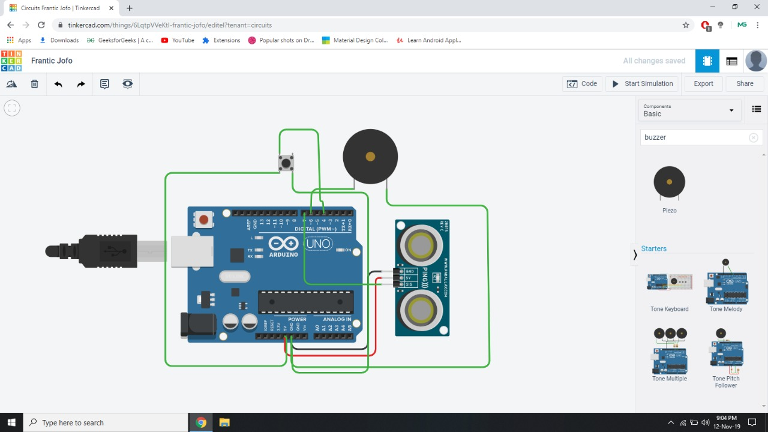

**Working of the project :-**

We have used a small hack to make this RF remote control circuit to work. Normally while using this 433 MHz module requires an Encoder and Decoder or two MCU to work. But, in our application we just need the receiver to detect if the transmitter is sending some signals. So the Data pin of the transmitter is connected to Ground or Vcc of the supply.

The data pin of the receiver is passed through an RC filter and then given to the Arduino as shown below. Now, whenever the button is pressed the Receiver output some constant ADC value repeatedly. This repetition cannot be observed when the button is not pressed. So we write the Arduino program to check for repeated values to detect if the button is pressed. So that is how a Blind person can track his stick.

**Software Code OF the Project :-**

**#define BLYNK_PRINT Serial  
  
#include <ESP8266WiFi.h>  
#include <BlynkSimpleEsp8266.h>  
#define TRIGGERPIN D2  
#define ECHOPIN D1  
#define BUZZER D3  
  
  
char auth[] = "vSC8oc9QI96Ow-pOS8AIehCkBBP6VR_t";  
  
char ssid[] = "Redmi";  
char pass[] = "87654321";  
  
WidgetLCD lcd(V1);  
int cm, per;  
void setup()  
{  
  Serial.begin(9600);  
    
  pinMode(TRIGGERPIN, OUTPUT);  
  pinMode(ECHOPIN, INPUT);  
    
  Blynk.begin(auth, ssid, pass);  
  
  pinMode(BUZZER, OUTPUT);  
  lcd.clear();   
}  
  
void loop()  
{  
  
  long duration, distance;  
  
    
  digitalWrite(TRIGGERPIN, LOW);    
  delayMicroseconds(3);   
  digitalWrite(TRIGGERPIN, HIGH);  
  delayMicroseconds(12);   
  digitalWrite(TRIGGERPIN, LOW);  
  duration = pulseIn(ECHOPIN, HIGH);  
    
    
  cm = (duration/2) / 29.1;  
    
    
  Serial.print(cm);  
  Serial.println(" Cm");  
      
 if(cm<250 && cm>5)  
  {  
      lcd.print(0,0,"ALL IS GOOD");  
}  
 if(cm < 5)  
  {  
  
     lcd.print(0,0,"OBJECT AHEAD");  
    
     digitalWrite(BUZZER,HIGH);  
     delay(3000);  
     lcd.clear();  
     digitalWrite(BUZZER,LOW);  
   }  
  
  delay(250);  
  Blynk.run();  
}**

**BILL OF MATERIALS REQUIRED :-**

